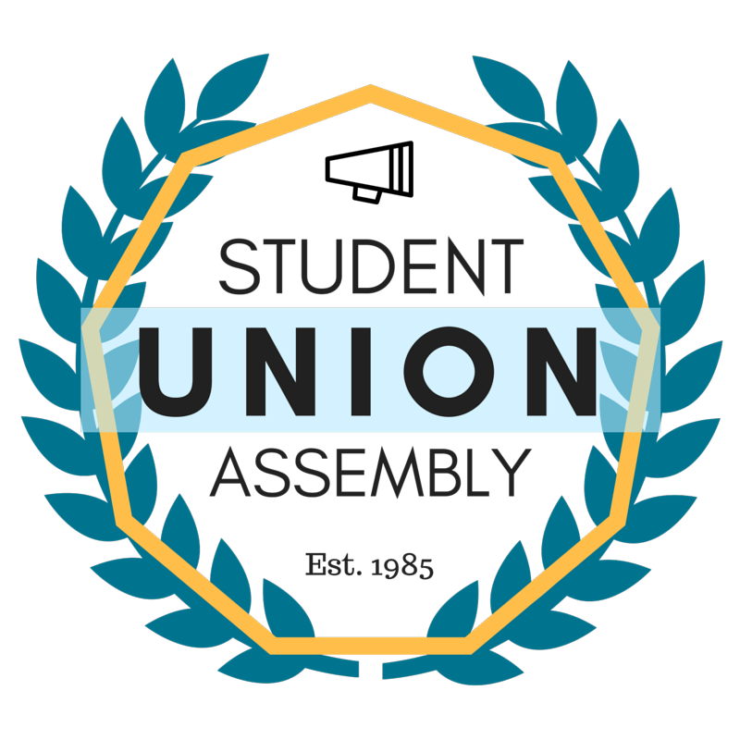
Student Union Assembly
Monthly Report
________________________________________________________________________________
SUA Mailstop: SOAR, 1156 High Street, Santa Cruz CA 95064 • P: 831.459.4838
suapres@ucsc.edu • sua.ucsc.edu
Under My duties as Vice President of Diversity and Inclusion of the Student Union Assembly and Article III Section A Subsection 6(l) of the SUA Constitution, I present my February 2017 monthly report and evaluation to the Assembly. I will outline all of my events, logistical planning, activities and constructive criticism with areas of improvement in hopes of providing a detailed account in the month’s report.

Ongoing Projects
MLK Convocation
This month I attended meetings for the MLK Convocation Planning committee. We have been able to replace the speaker with another well qualified speaker. I have begun to outreach and advertise for the event.
The event was hosted and was a success.
SUA Open House
Attended and Hosted SUA Open House for Recruitment.
Police Chief Meeting
This month I met with Chief Nader to discuss the content of the event we are planning for April. We discussed feedback I received from the SUA. Chief Nader was receptive to most ideas and he is very willing to accommodate to the wishes of the SUA to best of his abilities.
Committee on Affirmative Action and Diversity
This month I met with CAAD and we discussed TOE hires along with issues regarding pay for faculty at UCSC in relation to other UCs, this relates to an issue of retention and diversity. Faculty may not be able to live in Santa Cruz if they cannot afford to pay for housing.
Chancellor’s Office of Diversity and Inclusion
I have met with Chief Diversity Officer for Staff and Students, Linda. We discussed the projects she is currently working on and discussed her attending an SUA meeting, she was very receptive to the idea. Based on feedback from the SUA, I will schedule her to come sometime in March.
SACNAS
I have met with SACNAS leadership and we continued to plan logistics for the event with Watsonville High School which will be in mid-march.
STEM Diversity
After discussion about how we can help students in STEM and undocumented students simultaneously. This month I proposed a funding proposal to fund the needs of undocumented students in STEM. I will follow through with the official request in next week’s meeting.
NCAA Athletics
This month after discussion and collaboration with representatives from SCA, we have planned to design and make posters for NCAA Athletics. I submitted a funding proposal and a funding request to the SUA and we will finalize the request next meeting when all designs are submitted.
Feedback
I am concerned that we may lose a great advisor for next year’s SUA. I would recommend increasing pay for SUA advisor for next year’s budget. The advisor is a CRUCIAL role to the SUA.

